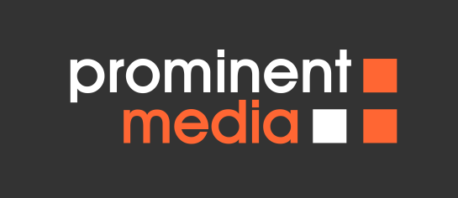

CLIENT QUESTIONNAIRE

The purpose of this questionnaire is to gather specific information about your website project. The more accurate you are able to be now, the better we will be at meeting your needs. Please be as thorough as possible and feel free to use as much space as you need.

- Please describe your organization in a few sentences:

- Why do you want to have a new web site, or have your current site redesigned?

- What goals do you have for this web project? (i.e. increase sales, build a solid brand, etc.)

- Who will be the primary target audience of this web site? (i.e. existing clients, potential new customers, internal employees)

- Do you have a brief statement that sums up your competitive advantage?

- Who will be the primary contact from your organisation for this project?

- Does this project have a strict deadline? If so, when is it?

- Please provide examples of other web sites within or outside of your industry that are appealing to you, and why.

- What are your favourite, and least favourite features of a web site?

- Do you have any materials such as text content, graphics, logos, etc. already prepared and ready for this project?

- Have any other web designers or contractors already worked on your web site? How do you feel about the work that they accomplished?

- Please list your top few competitors and their web site URLs (if applicable).

- How would your best clients describe you in 3-5 words?
- Are there any colours, fonts or branding guidelines we need to be particularly aware of?
- Are there any specific marketing messages, straplines or slogans we should be aware of?
- Which three pages do you think will be most popular (apart from the homepage)?
- On a scale of 1 to 10, where 1 is ‘very conservative’ and 10 is ‘very extreme’, where would you like your design to sit?
- If you have any thoughts on the initial site map (or at least headings in the navigation bar) please list them below

